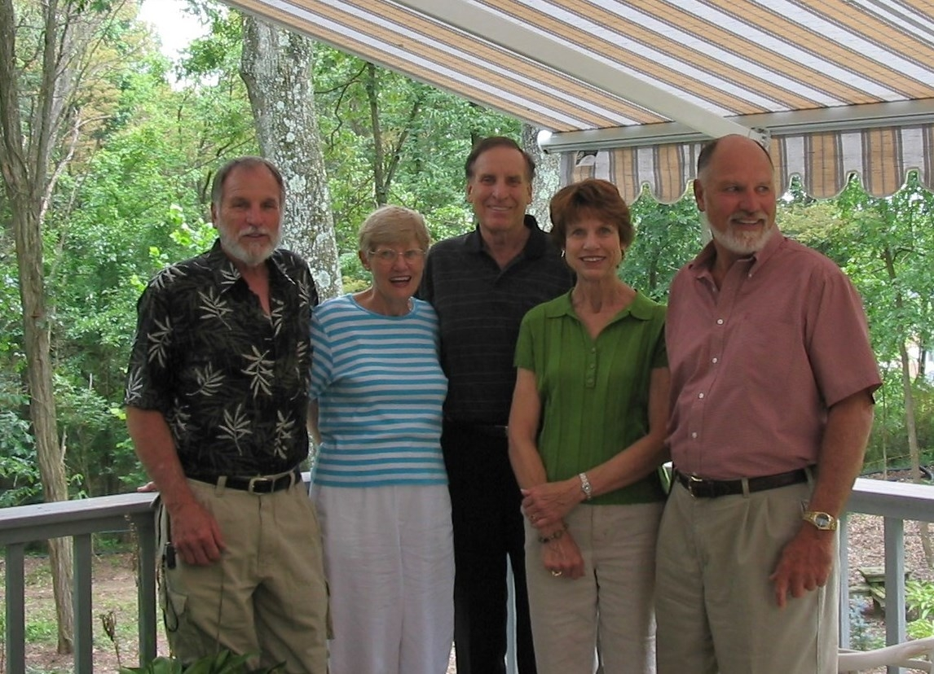

Nelson, Lois, Phil, Mary Jo, John - 30 July 2004

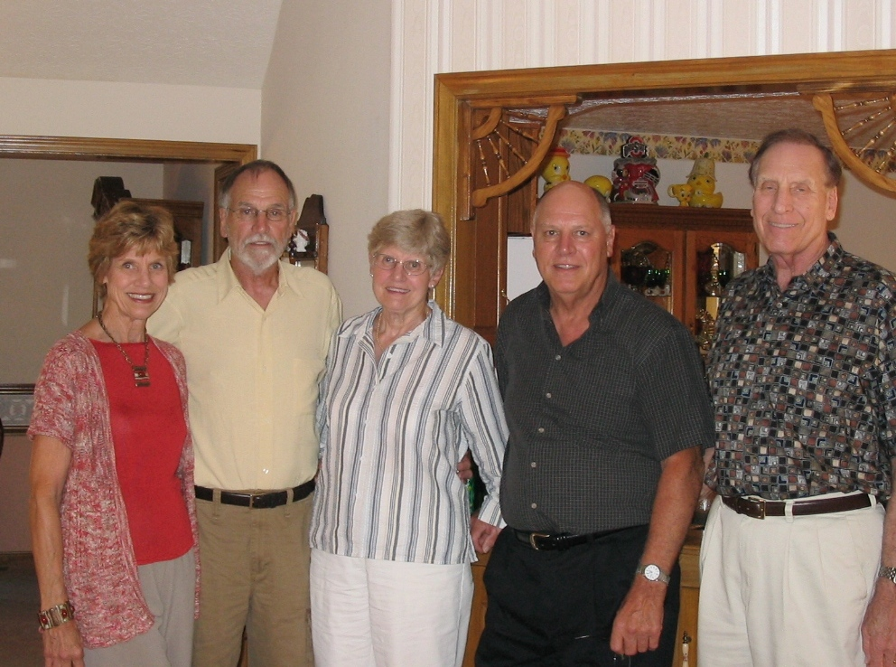

Mary Jo, Nelson, Lois, John, Philip – 2008